Helping the inner child heal from being the family scapegoat.

Week of 7/31/23 Journal Prompts Edited from 11/22/22

This video on scapegoating is
relevant to this week’s prompts.

I often say everyone had time in the doghouse in my family system. Someone was always the bad guy; therefore, our scapegoat role was fluid.

Some of us come from households where it was consistently one person, usually a child, who was in the role of the scapegoat or family therapy or systems theory. This identified patient is the reason on paper why the family is in therapy. A good family therapist knows the troubled teen is simply a sign of much more significant issues the teen is usually positively responding to.

And perhaps the biggest wound the family scapegoat must wrestle with is the betrayal of being used to hide bigger things.

The function of the scapegoat is a distraction from toxicity and parental failings. The scapegoat being ganged up by siblings or stepparents or actual parents or extended family was most like a cover-up in hiding any of the following factors:

• parental substance abuse
• parental cluster b personality disorder
• immature parent
• undiagnosed mental illness in a parent
• parental codependency and or marriage misery
• parental vicarious living, such as with a golden child
• parental untreated trauma

The central theme in a toxic family around the scapegoat is drama and needing a lousy guy that covers up the parental dysfunction and distracts.

Being the family scapegoat is genuinely horrific for a child. We’re so used to the term that I think it’s lost it’s impact on its meaning. If you identify as a family scapegoat or shamed child, any of these toxic parental tones will seem familiar to you.

“Well, if I hadn’t had to do your parent-teacher conference, your sister wouldn’t have gotten into trouble.” (blamed for things outside your control, not relevant to cause and effect, and made to feel like a burden for normal parental tasks)

“You’re why we have a flat time because YOU wanted to go for pizza on your birthday.”
(blamed for things outside your control, not relevant to cause and effect, and made to feel like a burden for normal parental tasks)

“I bet you left the lights on and weren’t home. (blamed and gaslit)

*You’re right now; you should be able to handle a bully.” (blamed for appropriate feelings and shamed for not being able to manage something beyond your development)

*I can’t believe I left work to take you to the hospital.” (gaslit and blamed to be made to feel like a burden for normal parental tasks)

All of that involves intense blame that becomes the child’s conditioning. Notice how there is a lot of magical thinking on behalf of the parent, which gaslights the child into buying into the magical thinking.

For example, if I didn’t have to go to your parent-teacher conference, your sister wouldn’t have gotten into trouble statement is twisting a nonrelevant event which is to gaslight the reality of the parent-teacher meeting and the sister’s trouble as connected.

A child growing up in this blame and gaslighting will start to look for connections between their actions and catastrophe that has consequences on others and eventually them.

When that child grows into adulthood, they can choose between taking on that meaning-making and blaming what they can rebel against.

In the following diagram, we can see these two strategies (rebel or comply) as stuck places that the adult was set up for by the toxic family. The commonalities are shame, abandonment, not being seen, predicting outcomes too much, and projections.

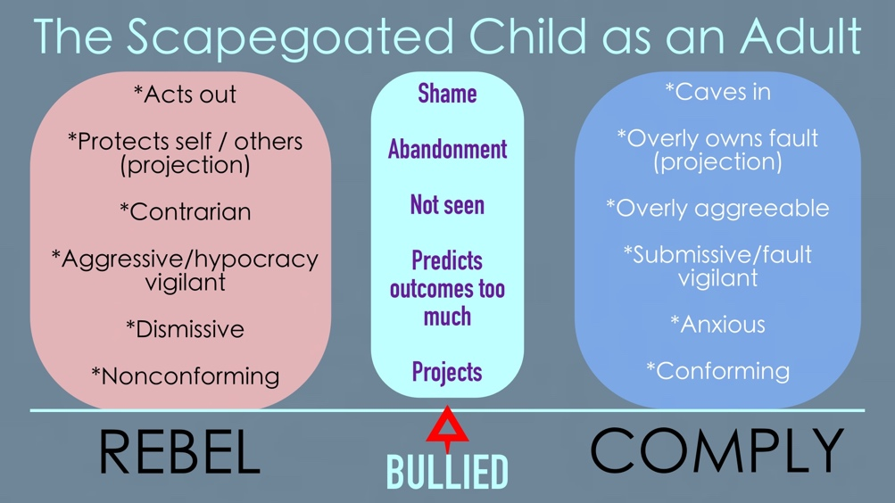

Often an adult who grew up as a scapegoat can get highly triggered by misunderstandings, mistakes, and the emotions of others.

Say a hypothetical situation where there was a simple miscommunication and an adult who grew up as a scapegoat brought the wrong thing to a potluck or dinner gathering.

A compliant scapegoat will own all the fault when there wasn’t any, overly apologize, experience a shame attack, and feel like being ridiculed is coming at some point.

The rebellious scapegoat in the same scenario might get defensive or guarded in shifting attention away from themselves by making it known they would have brought whatever had the instructions been clear.

Both types guard against what used to happen in their families, and those around them might experience them as having an over-the-top difficult reaction to a non-fault situation.

These are stuck places of how our history of being scapegoated can get in the way of how we want to be around others. You certainly can be combinations of both types, and the hypothetical example I gave was a non-fault one where no one was the bad guy in it. Some triggers for scapegoats aren’t that simple such as having a toxic boss or abusive partner.

Journal Prompt #1
If you or another family member were scapegoated, come up with three examples by your parent(s) and siblings.

Examples
“My father gave away my eight-year-old brother’s Christmas toys because he took the Lord’s name in vain at the dinner table, which enraged him. My father always treated my brother like his personal advisor, and he made an example out of him for the rest of us.”

“My mother made it a point in every social setting (teachers, other friends’ parents, family) to discuss my shortcomings sarcastically. (How I clean dishes, how I dress, how I’m not smart like my sister).

Journal Prompt #2
Reflect and write on what the parent got out of scapegoating you or another family member.

Examples
“My father was able to look like a wise tragic figure that he had to throw away my brother’s toys for taking the Lord’s name in vain. My father needed a villain to look good – like a character in his religious play. It was about my father looking pious, and my mother codependently soothed my father about it, not my brother.”

“My mother tried to get sympathy from random people about how much of a burden I was to her. It was for show. It was a cover-up because my mother hated her choices in life and wanted attention.”

Journal Prompt #3
How does the scapegoating fit into the victim, rescuer perpetrator formula (Karpman Drama Triangle)?

– see this video for reference https://www.youtube.com/watch?v=3LVQMgPhP3A&t=66s

Examples
In my father’s drama, my brother was the perpetrator (but he was an eight-year-old), my mother was the rescuer, and my father was the victim.

My brother was the victim, my father the perpetrator, and my mother the co-perpetrator.

Journal Prompt #4
What did the scapegoating cover-up in the toxic parenting?

Examples
“My father was an undiagnosed covert narcissist who used religion to gain attention and supply. It wasn’t about my brother at all or any of us. Her support of my father covered my mother’s trauma and toxic codependency.”

“My mother constantly pointing out my faults was to get attention from strangers to cover up that she was a shitty parent. His acting like I was a burden was to cover up that she hated her life choices and was miserable. The cover-up was covering up her dishonesty and disinterest in being a parent.”

Journal Prompt #5
How do you get triggered in adulthood to the old scapegoat role? Think of this over the course of a lifetime. Come up with a ten-item list if you identify as a scapegoat. Think comply/rebel or combination.

- If a problem comes up at work unrelated to me, I still think I’m going to get fired, and I’ll work harder.
- If my partner is in a bad mood, I get reactive, as if they are being passive-aggressive with me. It feels so much like it’s about me, but it isn’t.
- I’ll do anything with friends and those close to me to not have them get upset with me, so in a way, I’m so good with them that I try to control any issues they have with me.

Journal Prompt #6
What does your inner child believe about potential upset when triggers manifest?

- My inner child believes I will be fucked with, so it’s best to head it off in the past.
- My inner child believes there are big things I miss and need to watch out for because blame is just around the corner.
- My inner child feels that people don’t want me around in any group, so I exit before I say hello or get familiar.

Reparenting the inner child who was scapegoated is possible, but it isn’t easy because they devised great strategies to get through the family. Complying or rebelling have their good qualities, but like anything else, as adults, they keep our world small.

Think of how you want to be in the world from the adult space. For those that comply, it might look like having more self-respect and power. For those that rebel, it might look like softening and being more gracious to yourself and others.

